**Week 3:**

**Decomposition**

**Aim : To learn to decompose a problem to smaller problems**

**Activity 1:**

* **Ask the students to play the following game and ask them to tell the number of guesses made:**

[**https://scratch.mit.edu/projects/27227283/**](https://scratch.mit.edu/projects/27227283/)

* **Ask them to write an algorithm for the guessing game based on how they guessed.**
* **Ask the students to think of ways it can be optimized.**

**Activity 2:**

**Assume there is a team of 10 people. If the team is asked to search for a toy kept hidden in any of the rooms in the department, design a strategy to search for the toy.**

**Will the same strategy be a good one if there are 20 people in the team? Can you think of a better strategy?**

**Will the same strategy be a good one if there are 4 people in the team? Can you think of a better strategy?**

**Activity 3:**

**Ask the students to go through the Wikipedia page of Nonogram and understand the example given in the page and in the following page:**

[**https://docs.google.com/document/d/1Ndqn5-Uc-Vtc2GEGLx4YZ_gSHImVRzw_sJwTqcuiVTw/edit**](https://docs.google.com/document/d/1Ndqn5-Uc-Vtc2GEGLx4YZ_gSHImVRzw_sJwTqcuiVTw/edit)

**Then a) Solve the following puzzle:**

|  |  |  |  |  |  |  |  |  |  |
| --- | --- | --- | --- | --- | --- | --- | --- | --- | --- |
|  | **3** | **2** | **1,5** | **2, 2, 1** | **4** | **2, 2, 1** | **1,5** | **2** | **3** |
| **1,1** |  |  | --------- |  |  |  | --------- |  |  |
| **1,1** |  |  |  | --------- |  | --------- |  |  |  |
| **5** |  |  | --------- | --------- | --------- | --------- | --------- |  |  |
| **2,1,2** |  | --------- | --------- |  | --------- |  | --------- | --------- |  |
| **9** | --------- | --------- | --------- | --------- | --------- | --------- | --------- | --------- | --------- |
| **1,5,1** | --------- |  | --------- | --------- | --------- | --------- | --------- |  | --------- |
| **1,1,1,1** | --------- |  | --------- |  |  |  | --------- |  | --------- |
| **1,1** |  |  |  | --------- |  | --------- |  |  |  |
|  |  |  |  |  |  |  |  |  |  |

**b) Ask the students to create a puzzle on their own.**

**Activity 4: - If there is more time – Else keep for next week**

**Let the students try using a spreadsheet to get them prepared for data analysis in the next class**

**To teachers:**

**If the exact guess is made, then the minimum amount of time will be taken.**

**If binary search is done, it should take reasonable amount of time.**

**1) Algorithm for Guessing Game:**

**step1: Start**

**Step2: Declare a variable num and guess,GUESS**

**Step3: Using a randomize or randfunction or any other equivalent function , generate a random number greater than 1**

**Step4: Store the generated value in variable num**

**Step5: Assign GUESS as (1+num)/2**

**Step5: Get the guess from user as input**

**Step6: Check if number is equal to guess**

**Step7: If step6 is true , print "Guess Right"**

**Step8: If step6 is false, check if guess is less than number. if True, Display " Guess was less than number" and set GUESS as (1+num)/2**

**Step9: If step8 is false.check if guess is greater than number. if True, Display " Guess was greater than number" and set GUESS as (GUESS+num)/2.**

**Step10: If steps 8 and 9 are false, display "your Guess was right"**

**Step11: If steps 8 or 9 were true, repeat steps 5 to 9 till step10 is reached.**

**Srep12: Stop.**

**2) Team of 10. Design a strategy to search for a toy hidden in the dept.**

**Step1: Start by asking the team members to assemble .**

**Step2: If there are 10 people , divide**

**DIVIDE AND CONQUER**

**1. Start**

**2. Divide the people into teams based on the following formula:**

**Number of people per team=Total number of people/Number of rooms.**

**3. If there are remainder people, assign them to one team alternatingly.**

**4. Repeat step 3 until all the remainder people are assigned to a team.**

**5. Assign each team to a room.**

**6. Teams must first search objects with storage capacity.**

**7. If toy not found, teams must search corners.**

**8. If still toy not found, teams must search high places.**

**9. If still toy not found, teams must search locked containers with consent or permission.**

**10. Once toy is found, teams return it.**

**11. Stop**

**This would work for every case.**

**Spreadsheets:**

A **spreadsheet** is an interactive computer application for organization, analysis and storage of [data](https://en.wikipedia.org/wiki/Data) in [tabular](https://en.wikipedia.org/wiki/Table_(information)) form. Besides performing basic [arithmetic](https://en.wikipedia.org/wiki/Arithmetic) and [mathematical functions](https://en.wikipedia.org/wiki/Mathematical_function), modern spreadsheets provide built-in functions for common [financial](https://en.wikipedia.org/wiki/Financial) and [statistical](https://en.wikipedia.org/wiki/Statistical) operations.

The three most common general uses for spreadsheet software are to create budgets, produce graphs and charts, and for storing and sorting data. Data can be easily sorted and filtered ⎫ Data can be quickly analysed ⎫ Reports can be made more visual by using charts and graphs. Automating Tasks: Explore Excel Macro capability.

. Newer spreadsheet programs like Google Sheets and the latest versions of Microsoft Excel also allow multiple people to edit a spreadsheet at once, generally tracking changes so that people can be aware of what's been modified by whom.

Microsoft Excel disables macros by default because macros can be used to distribute viruses, potentially harming your computer. Even if an Excel document contains macros, Excel will not execute them unless you save the file in XLSM format.

Exxcel can automatiically updatte fiigures--stocck priices, FX rattes, ressults of sporrts gammes, fliight datta of aiirports, and any inffo in a sharred dattabase--from a liive datta sourrce. It surre beatts tediious manual entry on a daily basis.

Note that this functionality, which is called "Get & Transform/Power Query" isn't available in the 2007 version. Only 2010 and later:

If you're using 2010, download and install the Power Query Add-In. This is already built into 2013 and later.

Click "Power Query" (or "Data" > "New Query" > "From Other Sources" > "From Web")

In the "From Web" box, enter the URL. Provide user credential info if needed from the website itself. Click "OK."

Power Query will scan the webpage, and load the data in the "Navigator Pane" under the "Table View."

Select the table you want to connect to by clicking it from the list.

Click "Load," and the web data will be seen on your worksheet.

## 1) Pivot Tables

PivotTables summarise large amounts of Excel data from a database that is formatted where the first row contains headings and the other rows contain categories or values. The way the data is summarised is flexible but usually the Pivot Table will contain values summed over some or all of the categories.

If you’re new to creating PivotTables, Excel 2013 can analyze your data and recommend a PivotTable for you. Once you’re comfortable with PivotTables you can start from scratch and create your own.

To create a Pivot Table, make sure your data has column headings or table headers and that there are no blank rows. Click any cell in the range of cells or table.

INSERT > Tables > Recommended PivotTables

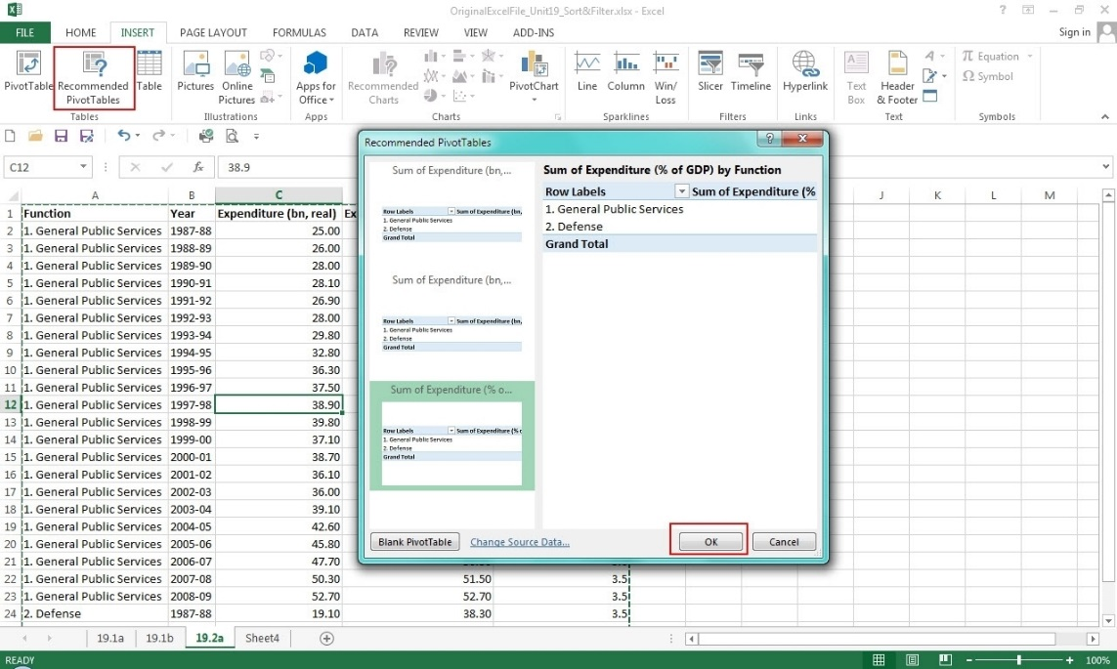

In the Recommended PivotTables dialogue box that launched, click any Pivot Table layout to get a preview then select the one that works best for you and click OK.

Excel will provide a selection of recommended PivotTables for your data. Excel then places the PivotTable on a new worksheet and shows the field list so that you can rearrange the data to best suit your needs. Again, make sure your data has column headings or table headers and no blank rows.

## 2) Conditional Formatting

Conditional formatting, as its name suggests, changes the format of a cell dependent on the content of the cell, or a range of cells, or another cell or cells in the workbook. Conditional formatting helps users to quickly focus on important aspects of a spreadsheet or to highlight errors and to identify important patterns in data.

Conditional formats can apply basic font and cell formatting such as number format, font colour and other font attributes, cell borders and cell fill colour. In addition, there is a range of graphical conditional formats that helps with visualising data by using icon sets, colour scales, or data bars.

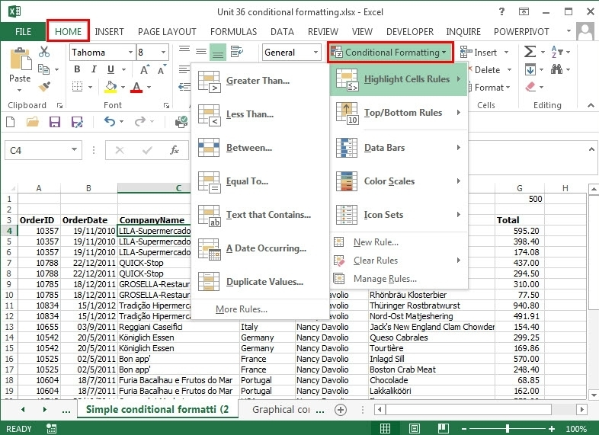

The chosen conditional format is applied to a cell based on a condition you set or a condition that Excel generates by comparing the values of cells in a range. So, for example, in a list of staff salaries, a conditional format could be applied to any salaries greater than a certain amount, any employees who joined before a specific date, or any employees with a specific name. The graphical conditional formats would be applied to the column of salaries and would, by default, be based on an analysis of the highest and lowest values in the list but this can be overridden if required.

Conditional formats can be applied very simply and quickly just to highlight certain cells or can be used in much more complicated and imaginative ways to show values graphically or automate the formatting of a spreadsheet.

## 3) Sorting and Filtering

Excel spreadsheets help us make sense of large amounts of data. To make it easier to find what you need, you can reorder the data or pick out just the data you need, based on parameters you set within Excel. [**Sorting and filtering**](https://www.youtube.com/watch?v=GkDlFVekBSQ) your data will save you time and make your spreadsheet more effective.

Suppose you have a list of hundreds of records including dates, ages, names, cities, and more. You can quickly organize the data to best suit your needs using Excel’s sort and filter features.

When you sort information in a worksheet, you can quickly organize the data and find values quickly. You can sort an entire worksheet or a range or table of data. Sorting can be done by one or more columns.

Let’s suppose you are a teacher and your class recently scored the following on a test:

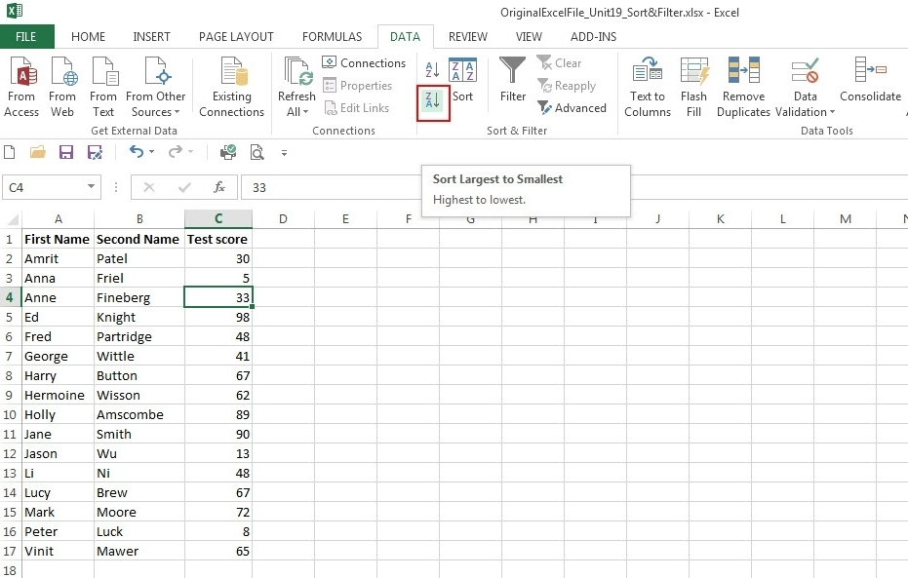

You could sort on first name (alphabetically), second name (alphabetically) or by the test score (numerically). In any of these cases, you would want the entire row to move together, so Jane Smith doesn’t become Jane Mawer. Let’s say you want to sort by the test scores, highest to lowest.

## 4) Basic Math

At the heart of any Excel spreadsheet are the numbers within the data. Using basic math functions to manipulate those numbers is one of the features that makes Excel so powerful.

Simple calculations can be entered into the formula bar in Excel just as they would be written on paper. As with all formulae in Excel, start a calculation with the = sign.

You can type the calculation you want to perform directly into the cell or the formula bar and when you press Enter the answer will show in the cell.

Another option is to use multiple cells to construct the formulae, as we see here (where cell A1 (or 87) plus cell A2 (or 16) equals cell A3 (or 103)):

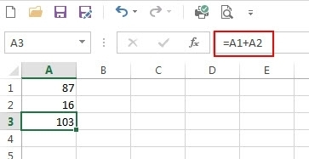

In order to perform the basic mathematical operations such as addition, subtraction, multiplication, or division to produce numeric results we use the following arithmetic operators:

+ (plus sign) for addition

- (minus sign) for subtraction

* (asterisk) for multiplication

/ (forward slash) for division

Excel interprets the = (equals) sign as indicating a calculation is to be performed and calculates according to the operators indicated from left to right.

For more complicated math calculations, check out our [**Working with Numbers**](https://filtered.com/user/course/bDnzmxdHrX/QZ6Lpy9hCP/TmFhPxkJWZ) Chapter.

## 5) Mixed Type Charts

Mixed type or combo (combination) charts combine two styles of charts, such as Excel’s column chart and line chart. This format can be helpful for displaying two different types of information or a range of values that varies greatly.

For example, we can use a column chart to show the number of homes sold between June and December and a line chart to make it easier to identify the average sale price by month. To create this chart, highlight all the data and select the Insert Combo Chart option in the Charts group of the INSERT ribbon tab